

**Software Development tools**

MAD(320)

Project :

**Kiwi Restaurant Cafe and Bar**

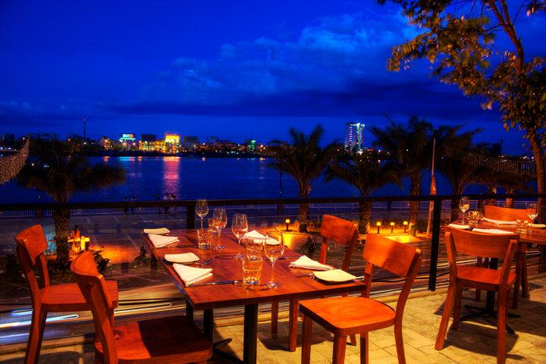

Submitted by : Jageer Singh Submitted to:

Rohit Yadav Silviya Paskaleva

# **Introduction**

Our Project is the Website of the Restaurant. In this project we put all things according to the client requirements. We put the Pictures of the Recipes, Drinks of the Restaurant. On this Website it has the Menu of the restaurant like: Drink Menu, Special Menu, Mains and Sweets. In this Website also have the feature of the Online Reservation and also take feedback from the Customers.

The main benefit of this Website is that it advertises the restaurant all over the world. Another one is that it reduces the stress of attending number of phone calls. To design this website we use HTML, CSS platform to create Frontend.

## **Purpose**

The main purpose of this website. But mainly A restaurant , or an eatery, is a business that prepares and serves food and drinks to customers. Meals are generally served and eaten on the premises. So that our website offers reasonably priced quality food, served quickly, in attractive, clean surroundings.

**Scope**

“Kiwi Restaurant Cafe and bar” website is designed for people who love food and drinks and also want to book their tables online to save their precious time. This website also provides different types of cuisines and special dishes for day for the people who are busy in their hectic life schedule so they can enjoy good environment and space in their specific time. The specialty about all these food items would be that they will be prepared in a clean and hygienic environment and made by the expert chefs.

Although this website does not have database so it cannot store the customers personal information after filling the form.

**Website Strategy**

Number of strategies will be followed and experimented on this website. These are just for the promotion, dynamic environment, customer attention and retention and attracting more customers. This will increase client profitability and our competing power in the market.

**General Description**

The website “Kiwi restaurant Cafe and bar” starts with the home page. At the top of the website there is a name of our restaurant with its logo (Kiwi Restaurant Cafe and Bar) and also provides options such as about us where the customers know about the history of the restaurant and its address and contact details. There are also other options like Menus, Gallery, Bar, Facility, Order and Feedback. Every page have the link pages so they can easily trace the snaps of cuisines, restaurant and gallery which definitely attracts the customers. In menu page have the link of different menus and also the bar link where customers have the link of drinks menu. Moreover, online order services are also included in the website where customers can easily order the food online. There is also online reservation form where the customer can reserve the table and also feedback form is present where the customers can share their feedback about the services of restaurant, website etc.

**Website Function**

This website will connect to the customers and the restaurant directly to each other so they can easily enjoy the menus and services of the restaurant.

**User Characteristics**

* User always want that Restaurant Serving high quality food
* The dining experience and restaurant ambience is other demand of customer
* Restaurant cleanliness so they can enjoy hygienic cuisines
* Something unique menus and
* The price factor is also important for the customers.

**Dine in Ordering**

Dine in Ordering, customers will view the menu, make online ordering and make a reservation table. This system allows to customers to place an order or allow him to cancel the order

**Flow Chart**

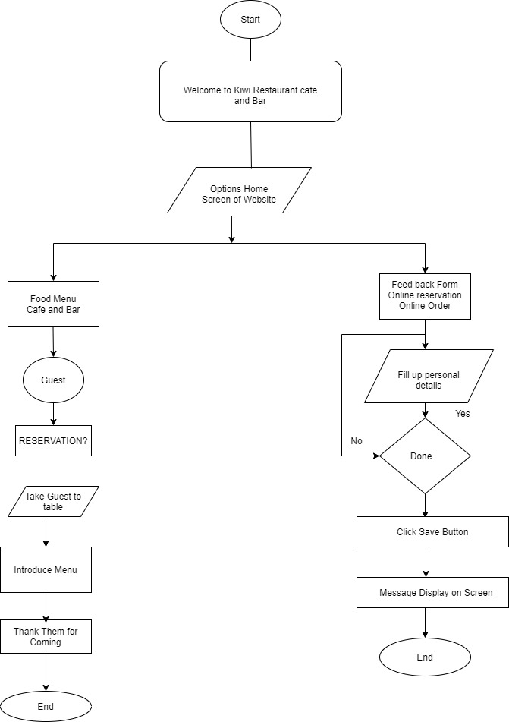

**Use Case**

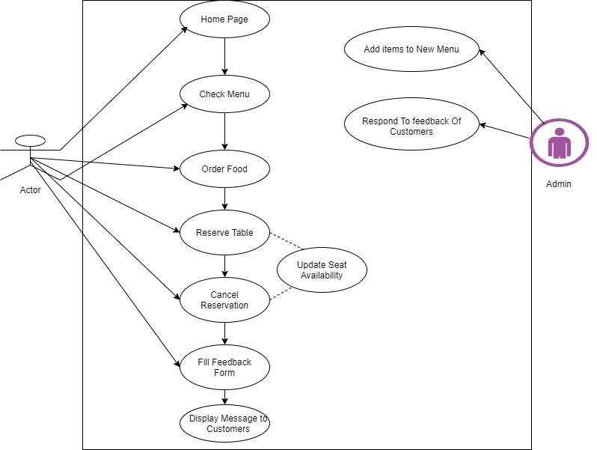

**Sequence Diagram**

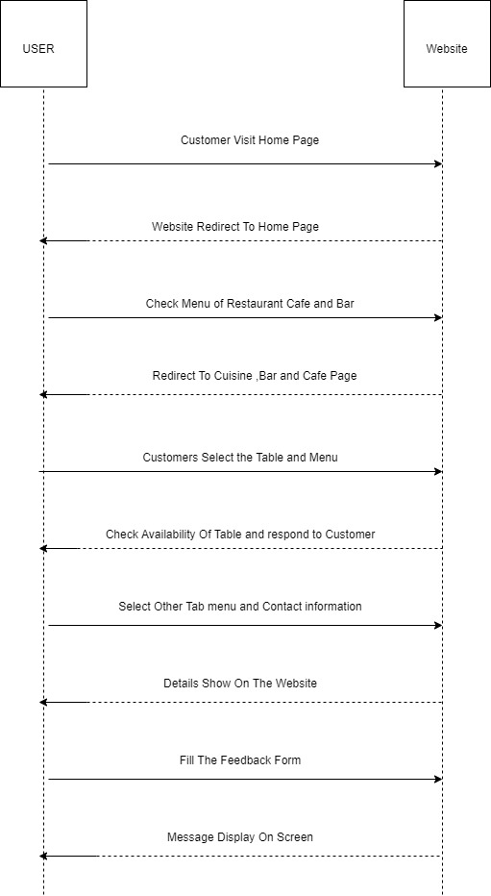

**Screen Flow**

Home Page

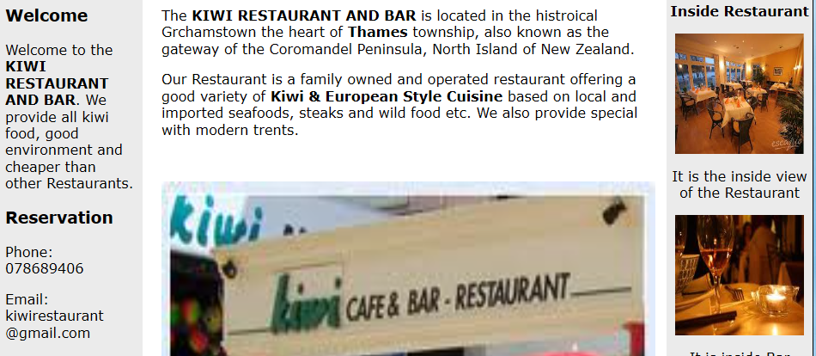

**About Us**

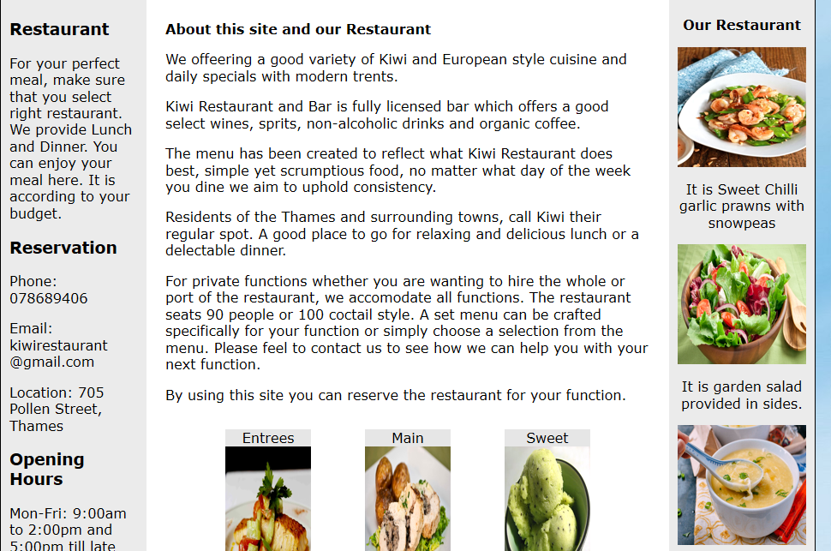

**Menu**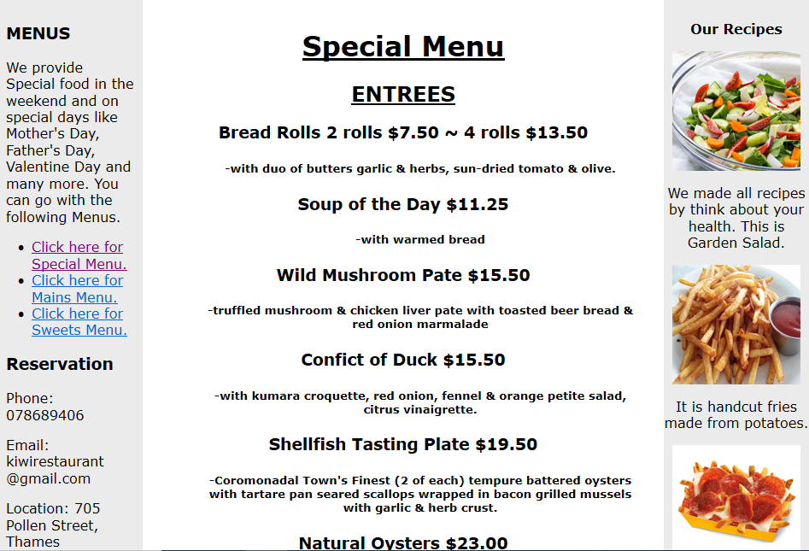

**Bar**

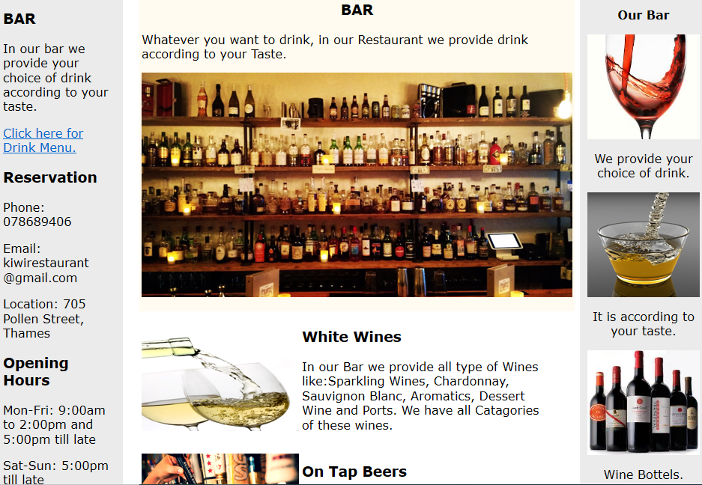

**Gallery**

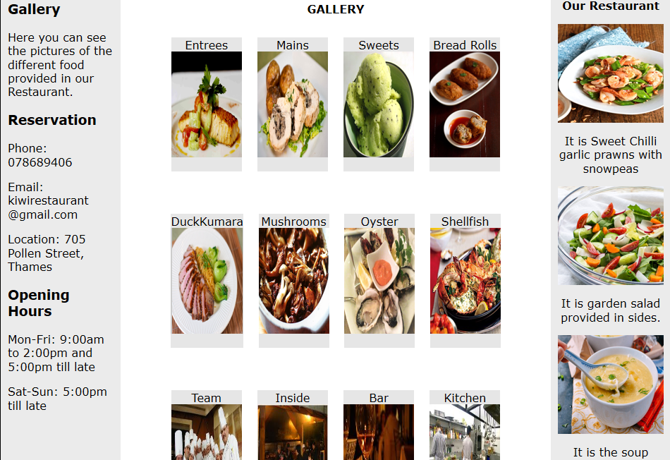

**Services**

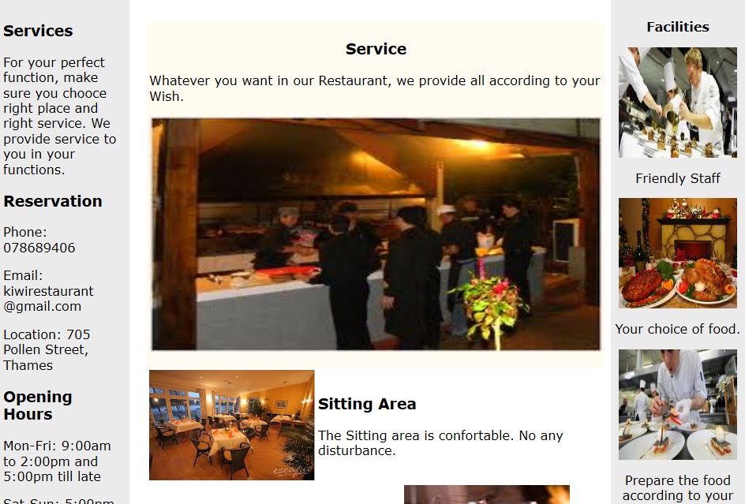

**Order Online**

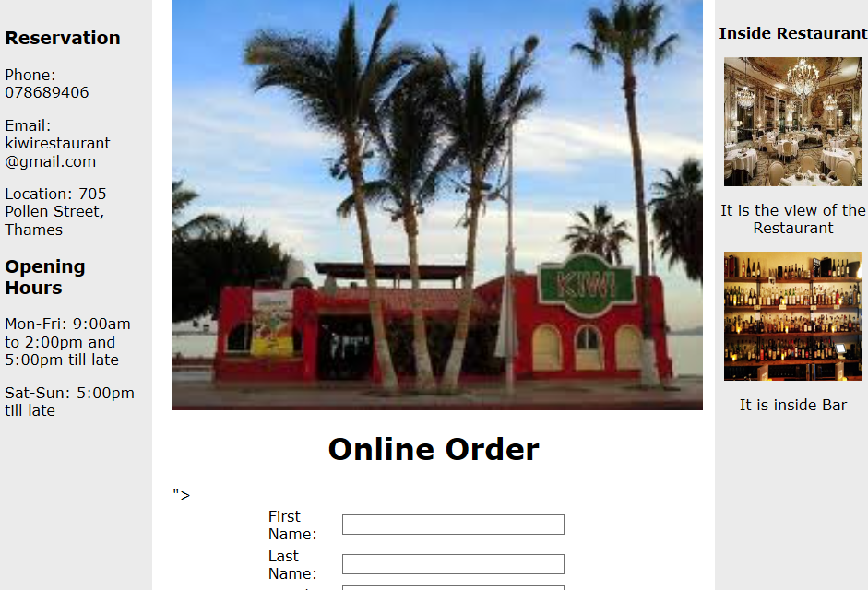

**FEEDBACK FORM**

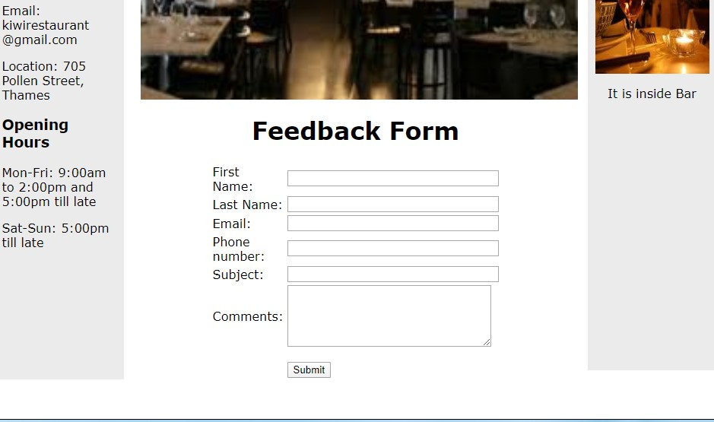

**Contact Information**

